**Assignment 7:SonarQube and Sonar Scanner**

Download SonarQube and Sonar Scanner

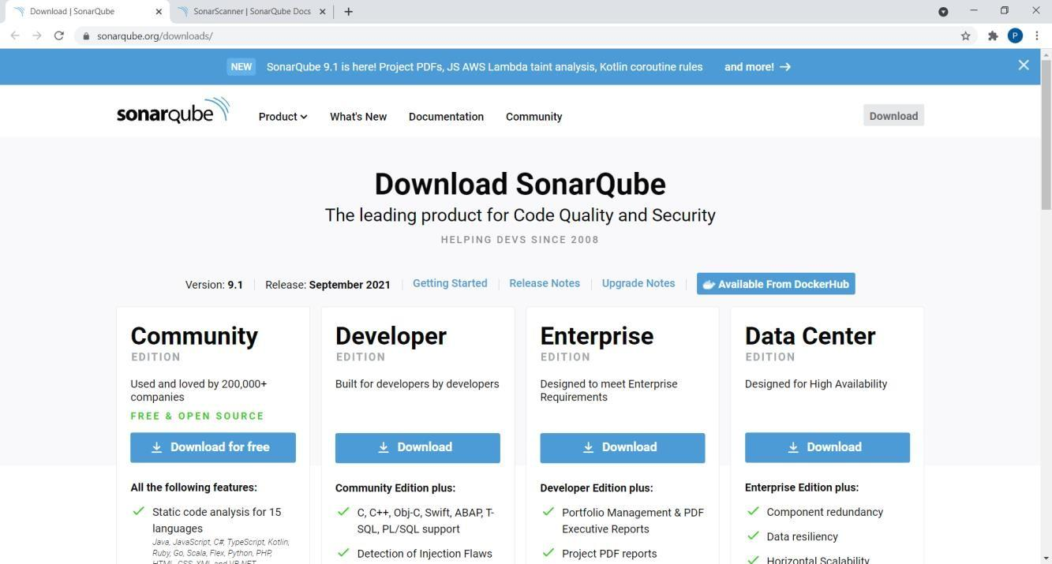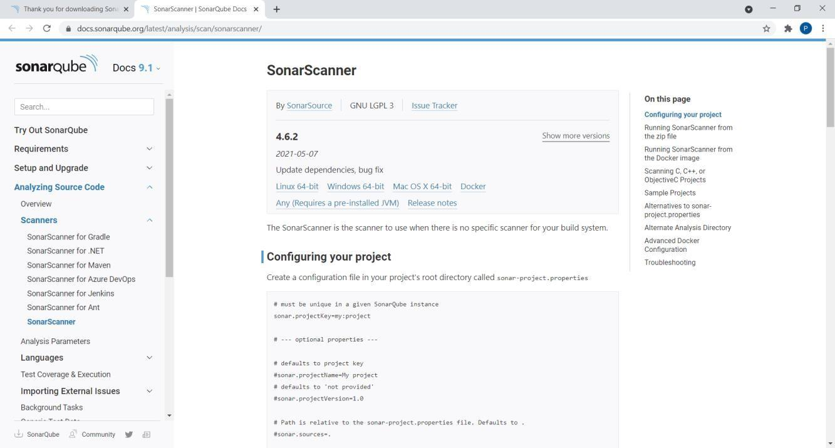

After downloading, set Environment Variables. Add “sonarqube-9.1.0.47736\bin” to Path.

Open command prompt. Run commands:

* cd “sonarqube-9.1.0.47736\bin\windows-x86-64”
* StartSonar.bat

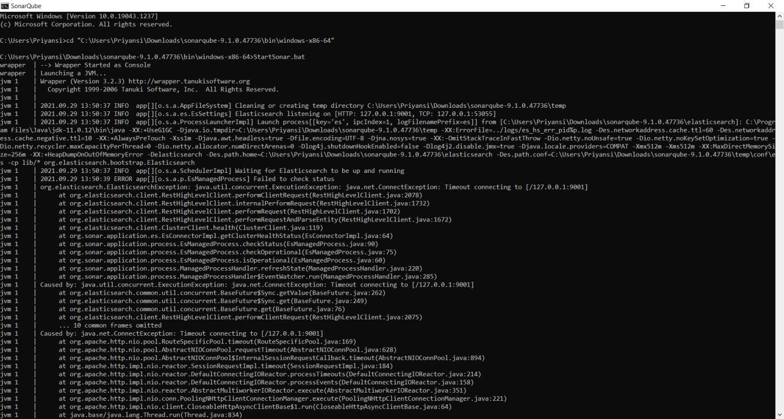

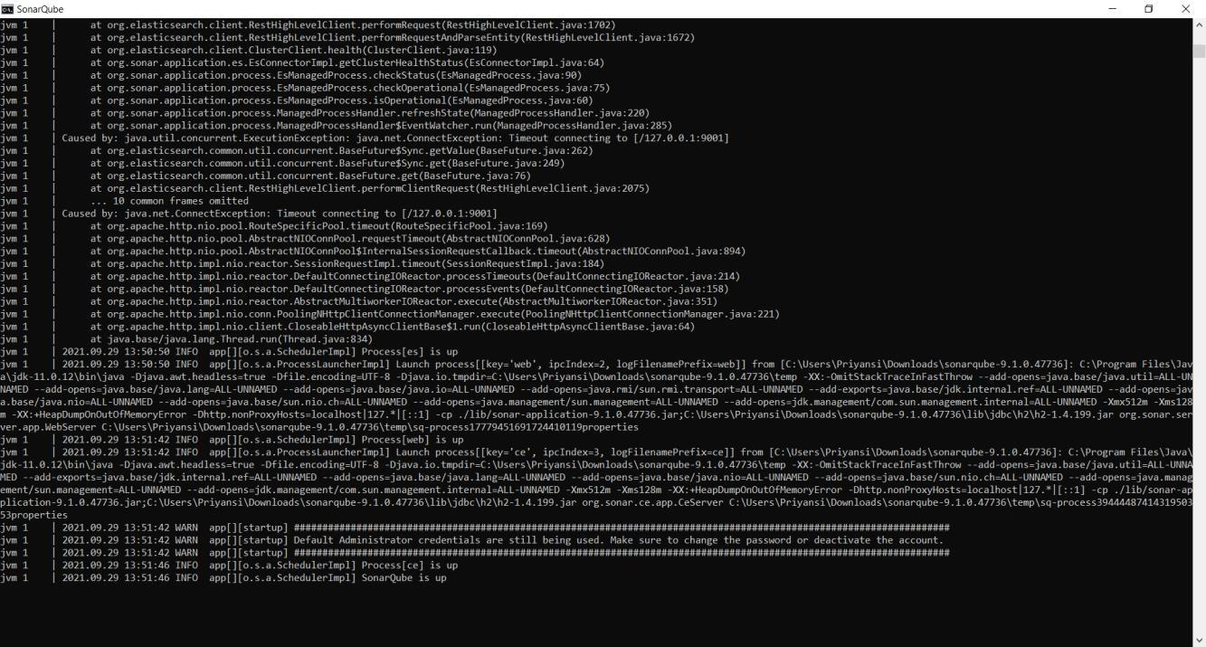

Open another command prompt. Run command:

* cd “sonar-scanner-4.6.2.2472-windows\bin”
* sonar-scanner

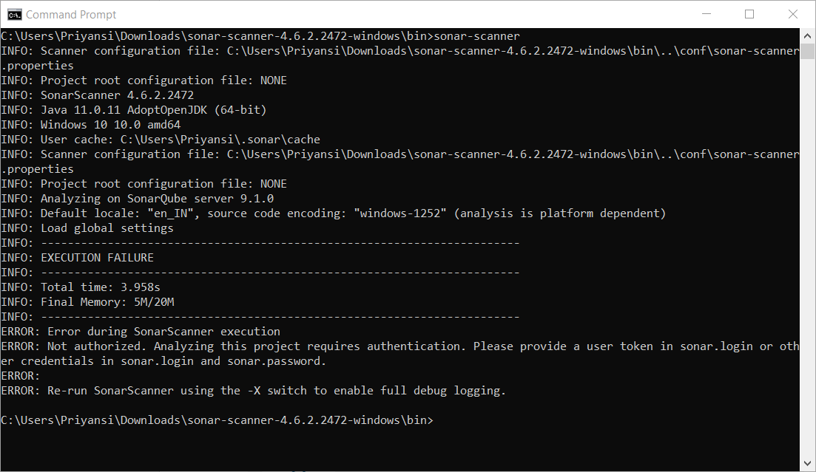

Server up and running on **localhost:9000**

Login using credentials as User: admin and Password: admin and Set a new password

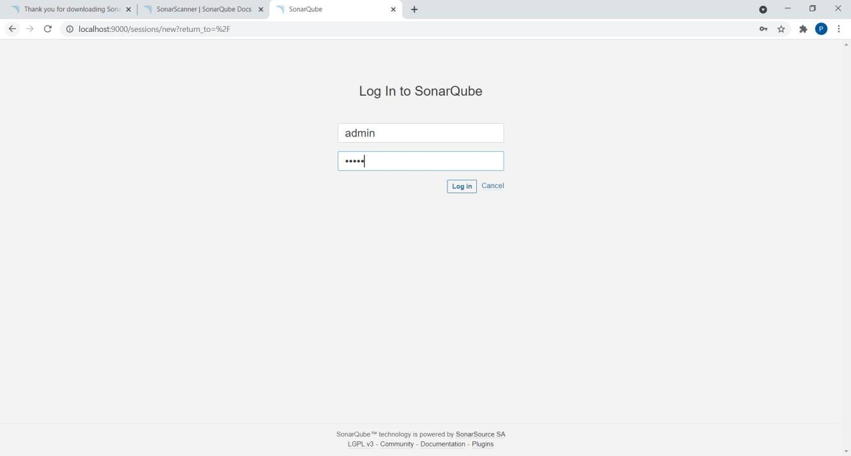

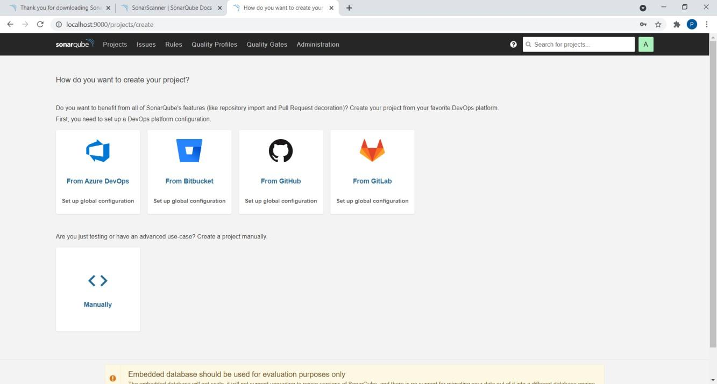

Click on Create a project **Manually.**

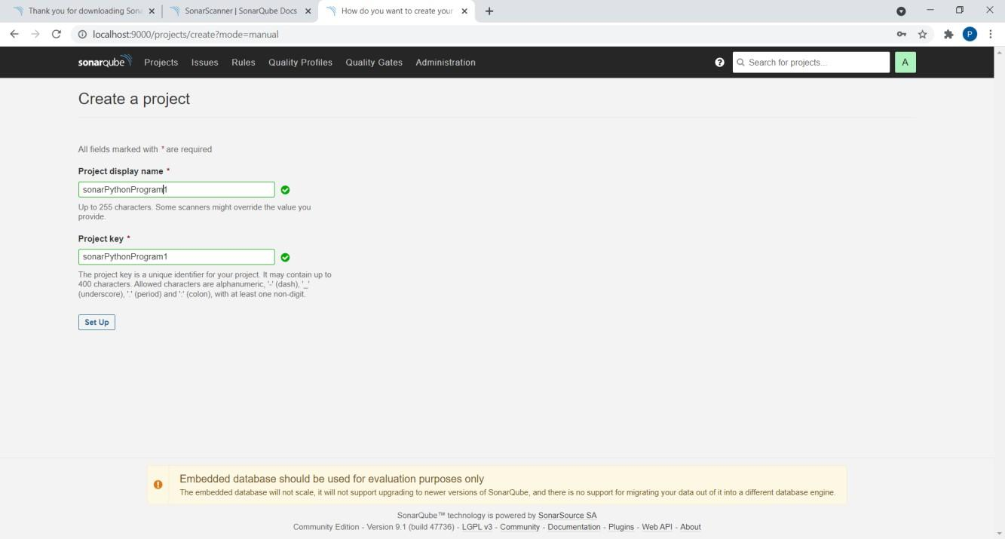

Give any Project display name.

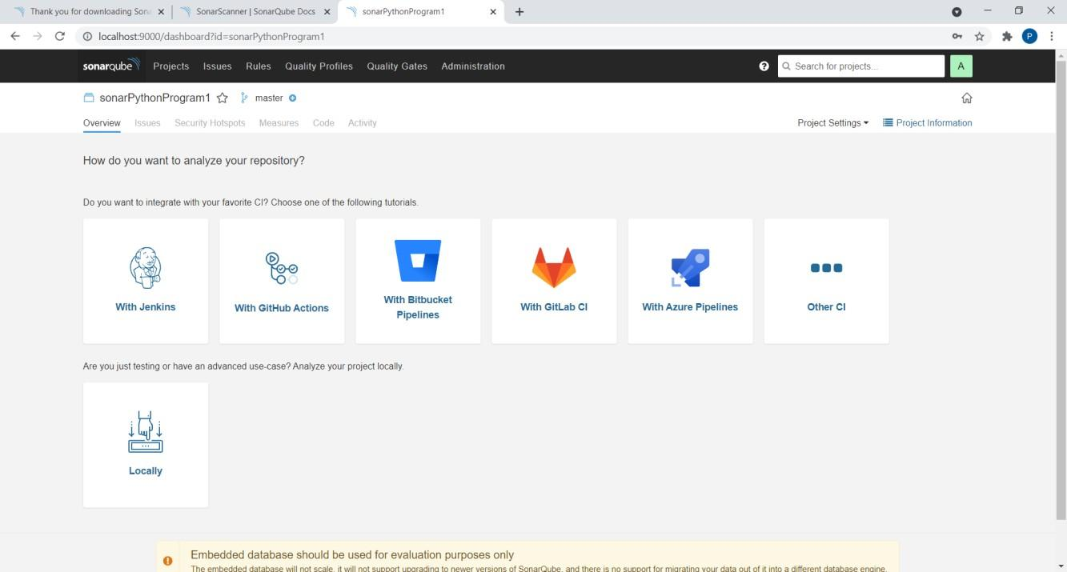

Click on **Locally.**

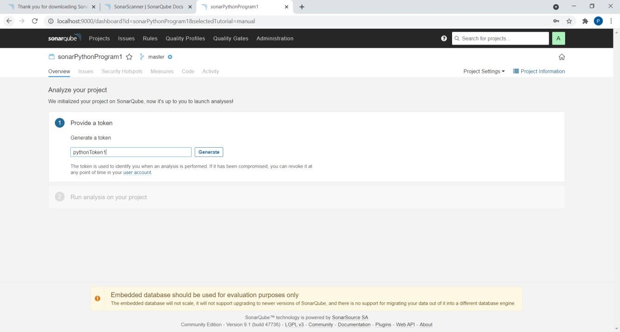

Give any name to token and click on **Generate.**

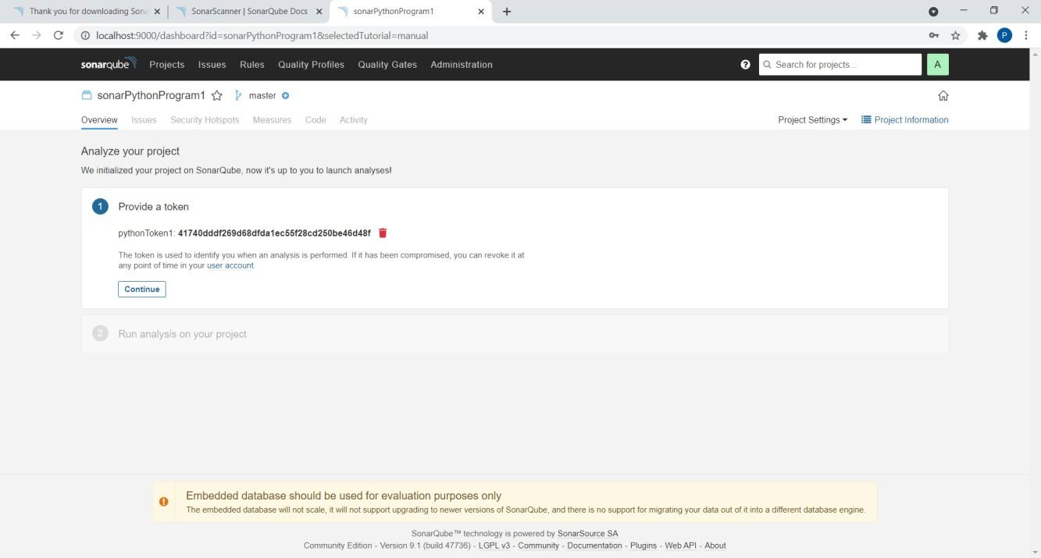

Click on **Continue.**

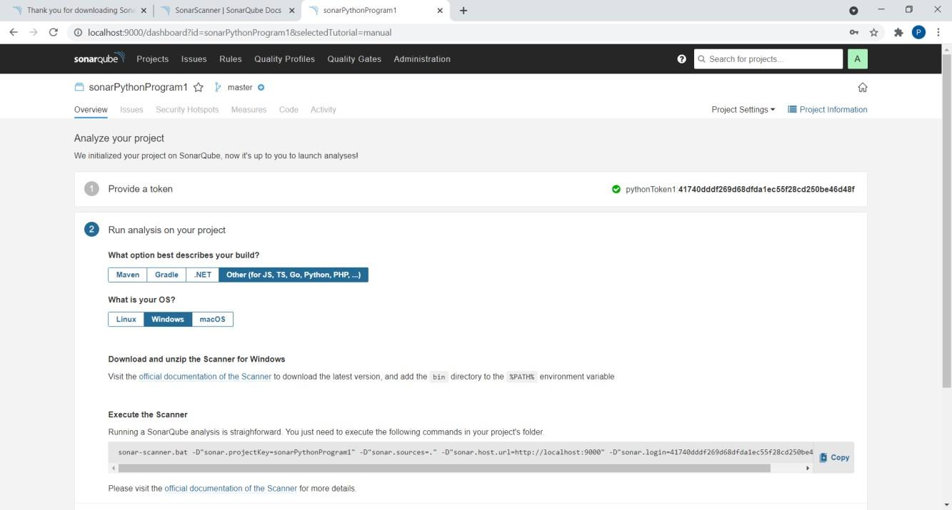

Save a Python program in a folder. class Solution(object):

def romanToInt(self, s):

roman =

{'I':1,'V':5,'X':10,'L':50,'C':100,'D':500,'M':1000,'IV':4,'IX':9,'XL':40,'XC':90,'CD':400,'CM':900}

i = 0 num = " "

while i < len(s):

if i+1<len(s) and s[i:i+2] in roman:

num+=roman[s[i:i+2]] i+=2

else:

#print(i) num+=roman[s[i]] i+=1

return num ob1 = Solution()

print(ob1.romanToInt("III")) print(ob1.romanToInt("CDXLIII"))

Open command prompt in this folder and Run program using copied command. “sonar-scanner.bat -D"sonar.projectKey=sonarPythonProgram1" -D"sonar.sources=." -

D"sonar.host.url=http://localhost:9000" -D"sonar.login=41740dddf269d68dfda1ec55f28cd250be46d48f"

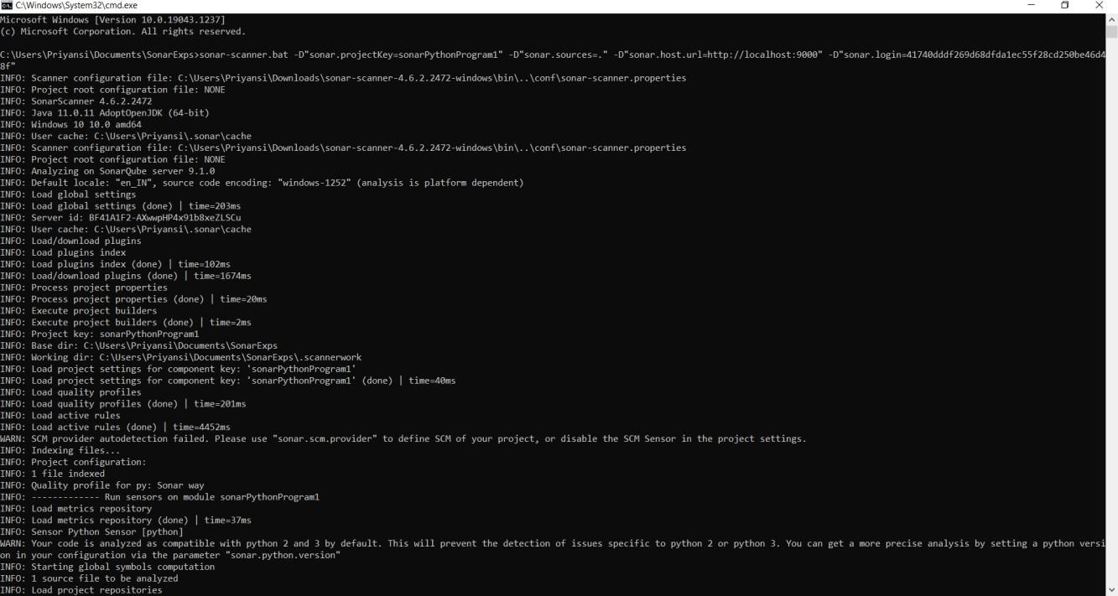

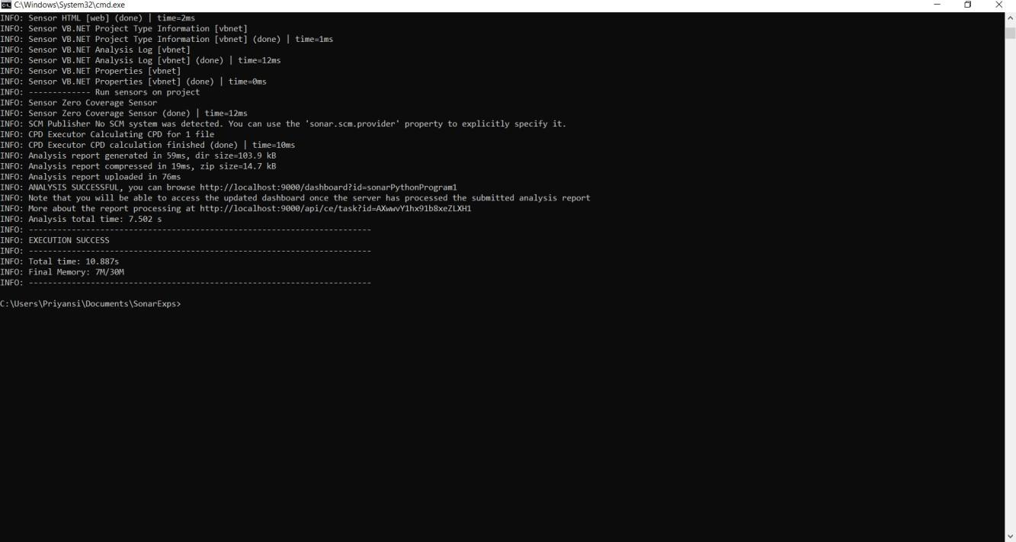

Given below is the inspection of code quality to perform automatic reviews with static analysis of code to detect bugs, code smells, and security vulnerabilities.

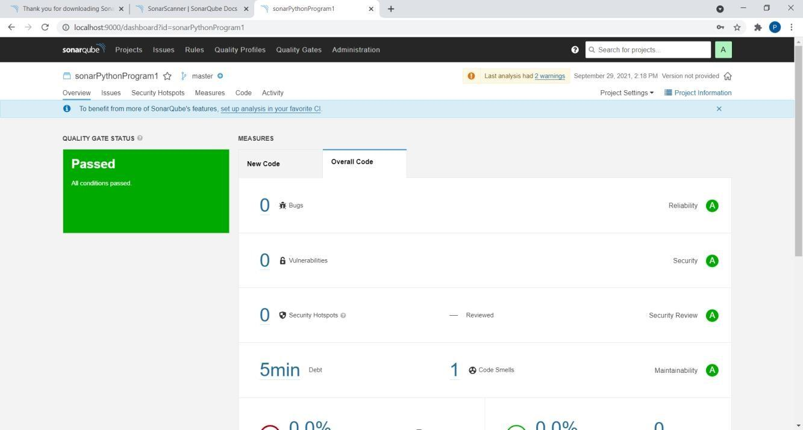

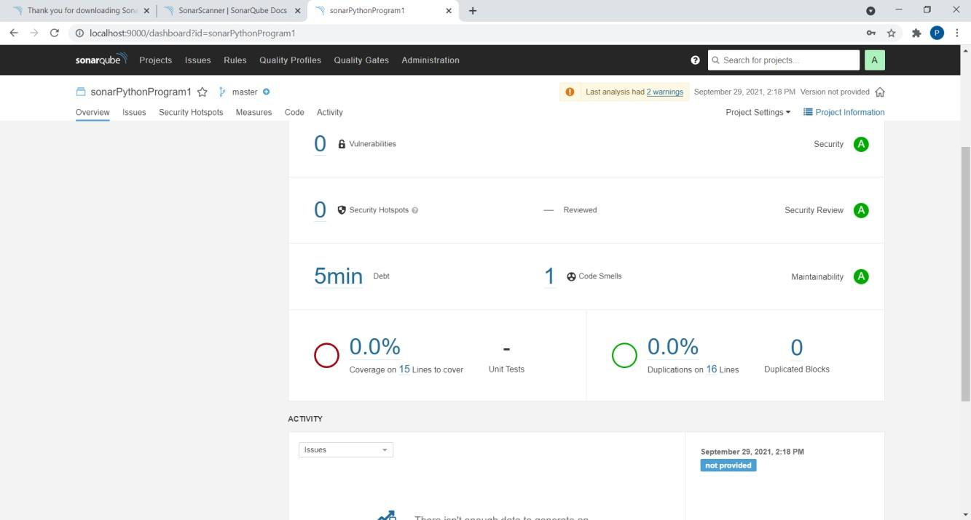

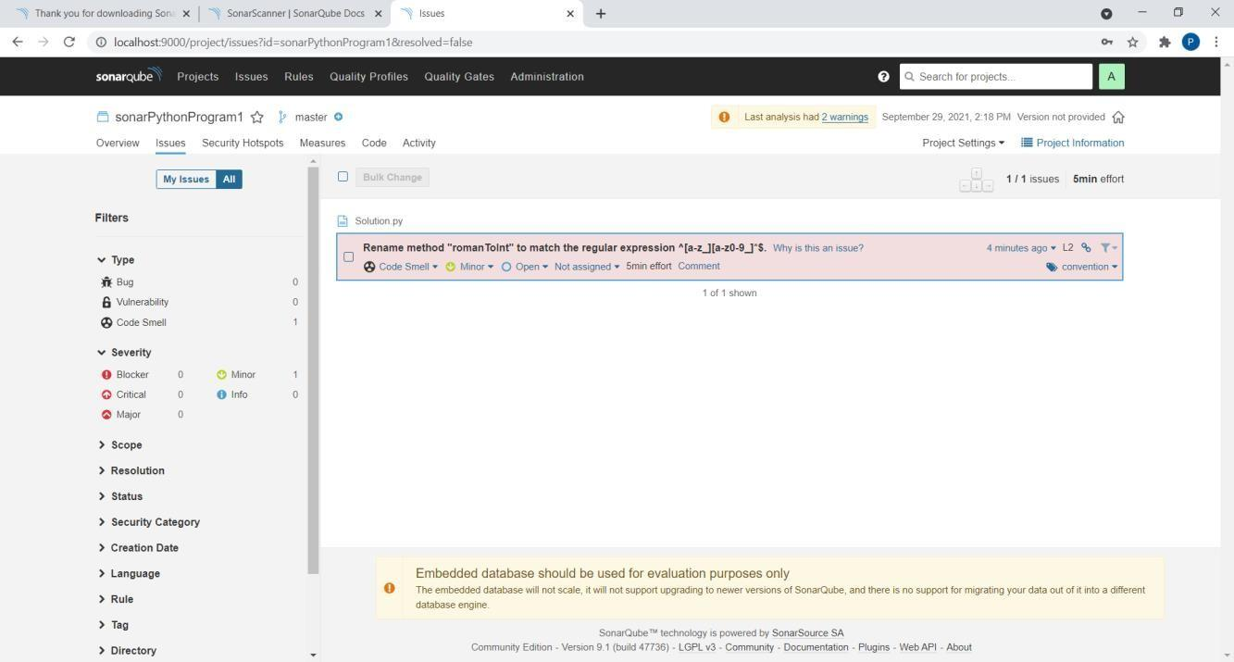

Press “**Ctrl + C**” to stop the server.

